|  |  |
| --- | --- |
|  | Vidyavardhini’s College of Engineering & Technology |
| Department of Computer Engineering |

|  |
| --- |
| Experiment No. 11 |
| Program to demonstrate data frame creation and Manipulation using Pandas |
| Date of Performance:8/4/24 |
| Date of Submission: 17/4/24 |

|  |  |
| --- | --- |
|  | Vidyavardhini’s College of Engineering & Technology |
| Department of Computer Engineering |

**Experiment No. 11**

**Title:** Program to demonstrate data frame creation and Manipulation using Pandas

**Aim:** To study and implement data frame creation and Manipulation using Pandas

**Objective:** To introduce Pandas package for python

**Theory:**

**Pandas** is an open-source library that is built on top of NumPy library. It is a Python package that offers various data structures and operations for manipulating numerical data and time series. It is mainly popular for importing and analyzing data much easier. Pandas is fast and it has high-performance & productivity for users.

**Code:  
my_pandas.py file:**

**# import module**

**import pandas as pd**

**# assign dataset**

**df = pd.read_csv("country_code.csv")**

**# display**

**print("Type-", type(df))**

|  |  |
| --- | --- |
|  | Vidyavardhini’s College of Engineering & Technology |
| Department of Computer Engineering |

**print(df)**

**country_code.csv:**

**name,age,marks,hobbies**

**Anjali,25,85.5,Reading,Traveling**

**Teena,22,78.0,Painting,Hiking**

**Smart,30,92.3,Photography,Cooking**

**Yami,28,89.7,Sports,Music**

**Output:**

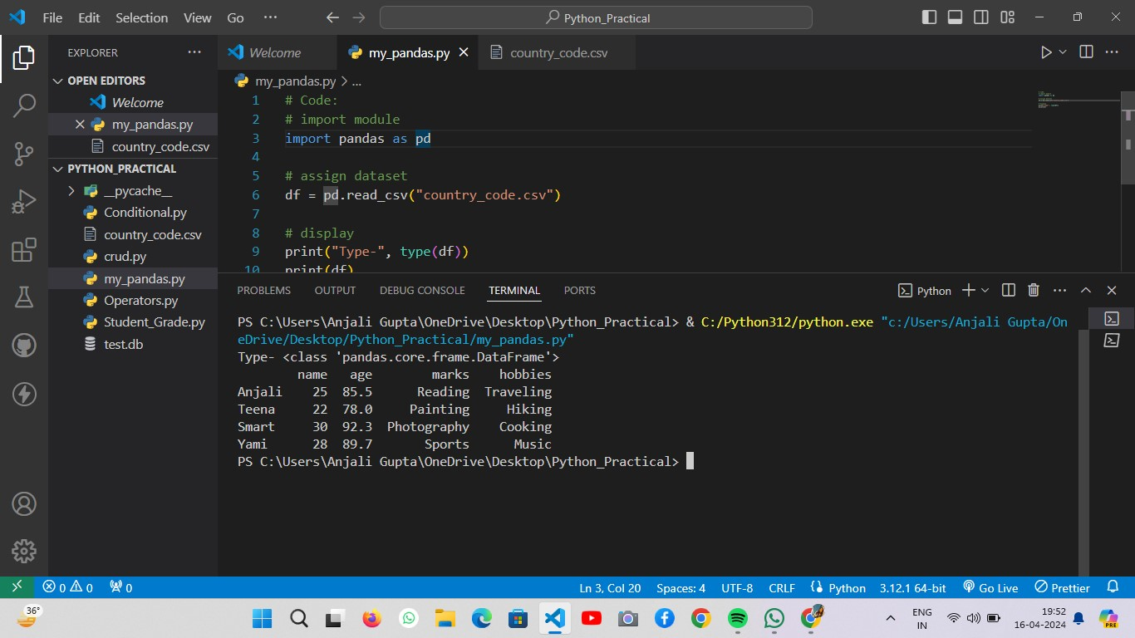

|  |  |
| --- | --- |
|  | Vidyavardhini’s College of Engineering & Technology |
| Department of Computer Engineering |

**Conclusion:**   
In conclusion, Pandas provides a powerful framework for creating and manipulating DataFrames, which are fundamental to data analysis in Python. With Pandas, users can efficiently handle structured data, perform various operations like filtering, grouping, and merging, and apply transformations easily. Its intuitive syntax and extensive functionality make it a preferred choice for data manipulation tasks. By leveraging Pandas, analysts and data scientists can streamline their workflows, extract insights, and derive value from their datasets effectively.